Grade 7 Accelerated · Unit 4 · Lesson 6  Order of Operations with Radicals  Question Bank - Additional 4.06 ANSWER KEY | Name  Date  Period

Show your work. Circle your final answer.
For questions 1 through 6, evaluate.
1. 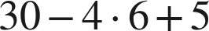
11
30 − 24 + 5.

2. 
12
One level, left to right: 6 · 2.

3. 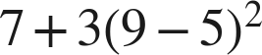
55
7 + 3(16).

4. 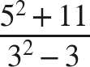
6
36 over 6.

5. 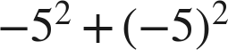
0
The exponent attaches to its own base; the parentheses decide what that base is.

6. 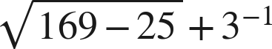
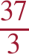
Under the bar: 144, whose root is 12.

For questions 7 and 8, evaluate. Each expression has more than one grouping symbol.
7. Evaluate each expression.
a. 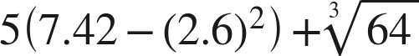
7.3
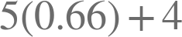.
b. 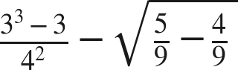
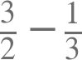.
c. 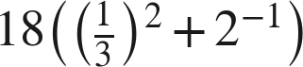
11
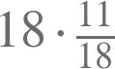.

8. Evaluate each expression.
a. 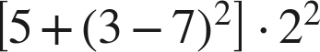
84
Innermost first: 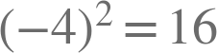, so the bracket is 21.
b. 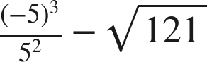
−16
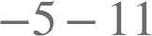.
c. 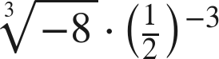
−16
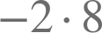.

Working backwards.
9. Find the value of that makes each statement true.
a. 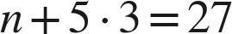
n = 12
b. 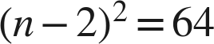, where is greater than 2
n = 10
c. 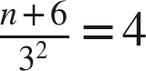
n = 30
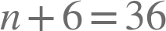.

Reading someone else's work.
10. Liesel says that , because addition comes before subtraction. Is she right? Explain, and give the correct value.
She is not right. Addition and subtraction are one level and are taken left to right, so  and then .
The same answer as Deshawn's, one level down: no rule puts either of a pair ahead of the other.

11. Which is the value of 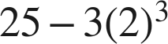 ?
○ A. 7
○ B. −191
● C. 1
○ D. 6,859
C

12. Select ALL of the expressions whose value is 9.
☒ A. 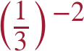
☐ B. 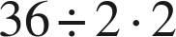
☒ C. 
☒ D. 
☐ E. 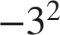
☒ F. 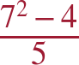
A, C, D and F

